Home

About

Contact

login

Next Door

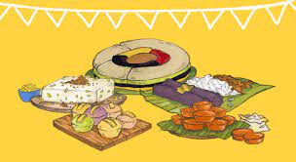

**Order now**

**Best Pilipino Food Snack**

**About my Food**

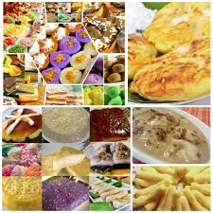 Blahh blahh blahh

Our Foods Menu

Kutchinta

Biko

Bibingka

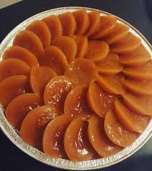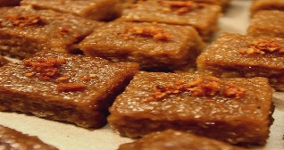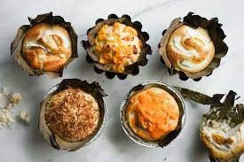

PRICE

PRICE

PRICE

Order Now  
Now

Order Now  
Now

Order Now  
Now

Got Some Queries, Feel Free to Contact Us

**Contact Us**

**About us**

**Order Food**

**Login**

**Services**

**Our Pages**

**Next Door**

**Submit**

Your Message

Mobile No.

Email

Name